JECRC 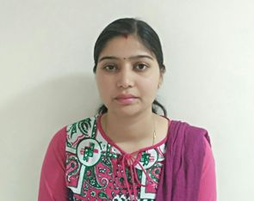
JAIPUR

INDIVIDUAL FACULTY DATA SHEET
Name of the faculty member | : | Ravita Saraswat
Present Designation | : | Assistant Professor
Email Id: ravita.ee@jecrc.ac.in
Contact Details: 9457488848

I. Particulars of Educational Qualification: (only completed)

Category | Name of the Degree | Specialization | Year of Passing | Name of the College | Name of the University
UG | B.tech | Electrical Engineering | 2011 | B.S.A college of engineering and technology | UPTU
PG | M.tech | Renewable Energy System | 2016 | NIT, Kurukshetra | NIT, Kurukshetra
Ph.D.

II. Academic Experience : 05

III. Industrial Experience : Nil

IV. Title of Ph.D. Thesis :

V. Awards/Achievements :

VI. Research/Specialization : Renewable Energy System

VII. Course Taught :

VIII. Refereed International Journal Publication : Journal Of Environmental and Analytical Toxicology

IX. International Conference Proceeding : IEEE conference 2016, GCRE NIT Patna

X. Books Written :

XI. M.Tech Thesis Guide : Dr. Sathans, Professor, NIT Kurukshetra

XII. PHD Thesis Guide :

XIII. Professional Body Membership :

